ANSWER PAGE
Surname, initial (In Block Letters): KABAI, M

Student Number: 215203569

(Please remove this page from the question paper and put it inside your answer book.
ALL THE STEPS FOR THE ANSWERS MUST BE THERE IN THE ANSWER BOOK)

ANSWER 1:

A | B | C | D | E | F | G
0 | 2 | 8 | 6 | 10 | 9 | 9
ANSWER 2:
2.1.
 | P | Q | R | S | T | W | X | Y | Z
P | 1 | 0 | 1 | 0 | 0 | 1 | 0 | 0 | 0
Q | 0 | 0 | 0 | 0 | 0 | 0 | 1 | 0 | 0
R | 1 | 0 | 0 | 0 | 0 | 0 | 1 | 0 | 0
S | 0 | 0 | 0 | 0 | 1 | 0 | 0 | 0 | 0
T | 1 | 0 | 0 | 0 | 0 | 1 | 0 | 0 | 0
W | 1 | 0 | 1 | 0 | 0 | 0 | 0 | 1 | 0
X | 1 | 0 | 0 | 0 | 0 | 0 | 0 | 0 | 0
Y | 0 | 0 | 0 | 0 | 0 | 0 | 0 | 0 | 1
Z | 1 | 0 | 0 | 0 | 0 | 0 | 0 | 0 | 0

2.2.
P | R → W
Q | X
R | X
S | 0
T | W
W | Y
X | 0
Y | Z
Z | 0

ANSWER 3 (Steps and the BFS and DFS tree must be drawn in the answer book):
3.1.
Steps for DFS
1. Push the starting node in the stack.
2. Loop until the stack is empty.
3. Pop the node from the stack inside loop call this node current.
4. Process the current node.
5. Traverse all the child nodes of the current node and push them into stack.
6. Repeat steps 3 to 5 until the stack is empty.

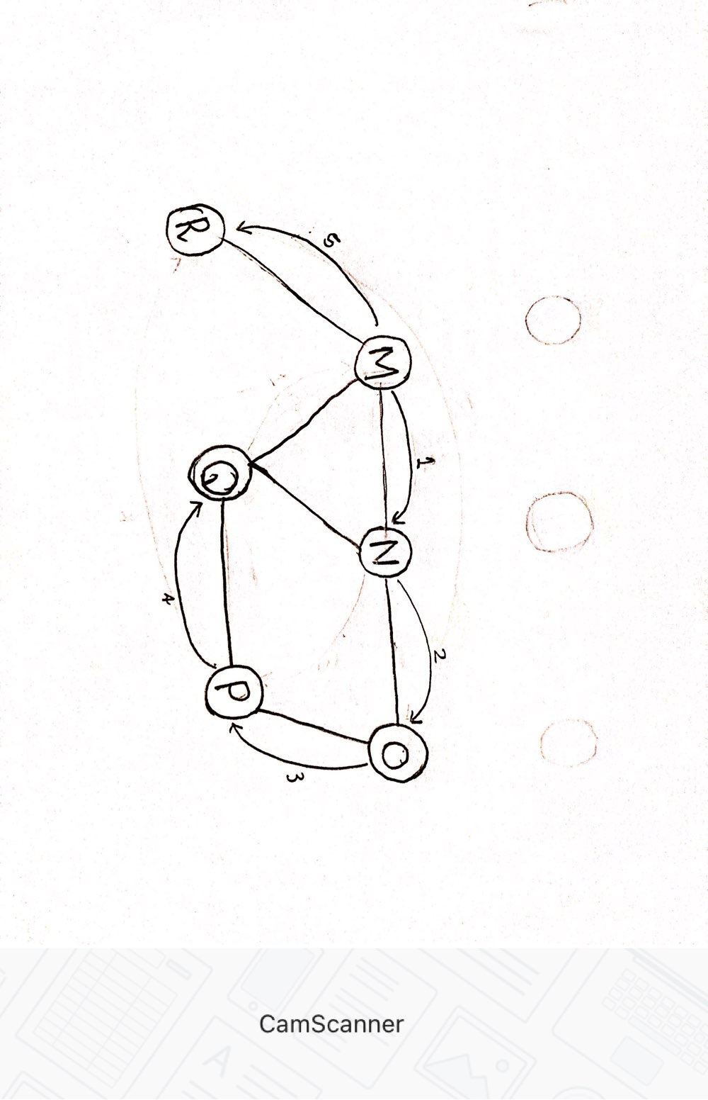
MNOPQR

3.2.
Steps for BFS
1. Push the starting node into the Queue.
2. Loop until the Queue is empty.
3. Remove a node from the Queue inside loop, call this node current.
4. Process the current node.
5. Traverse all the child nodes of the current node and push them into Queue.
6. Repeat steps 3 to 5 until Queue is empty.
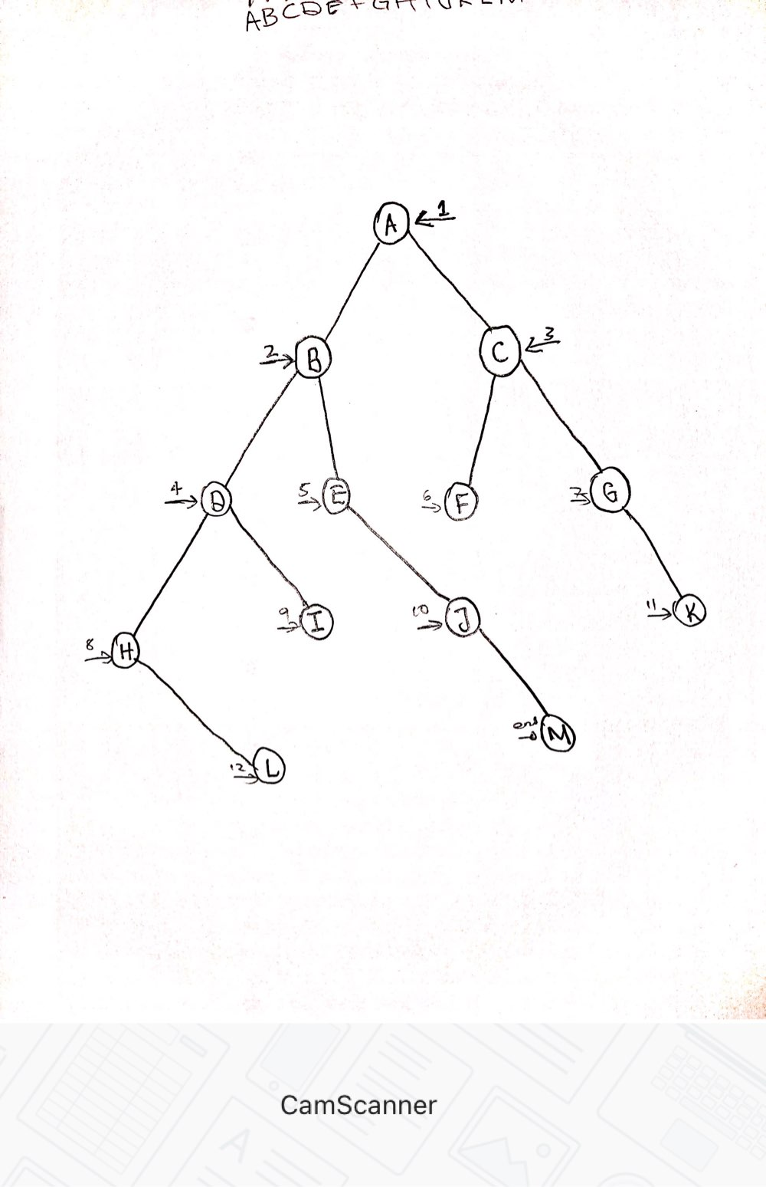
ABCDEFGHIJKLM

ANSWER 4:
4.1. Graph
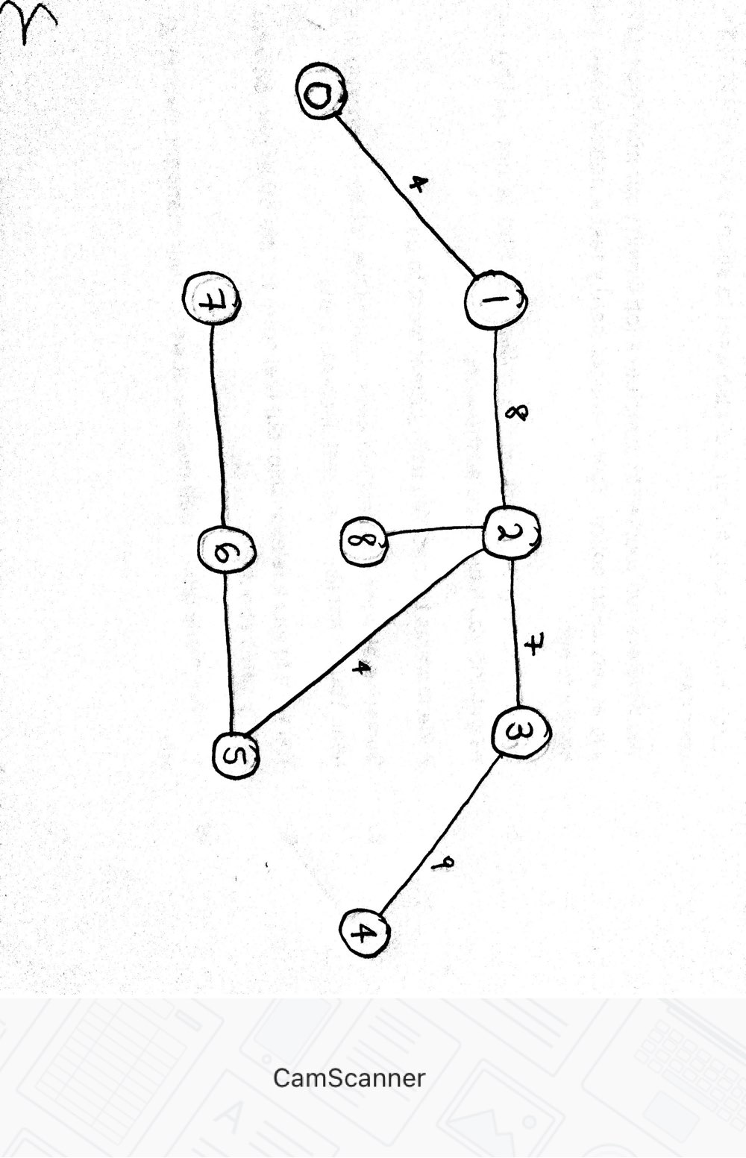
Total Weight

4 + 8 + 7 + 9 + 2 + 4 + 1 + 2 = 37

4.2. Graph
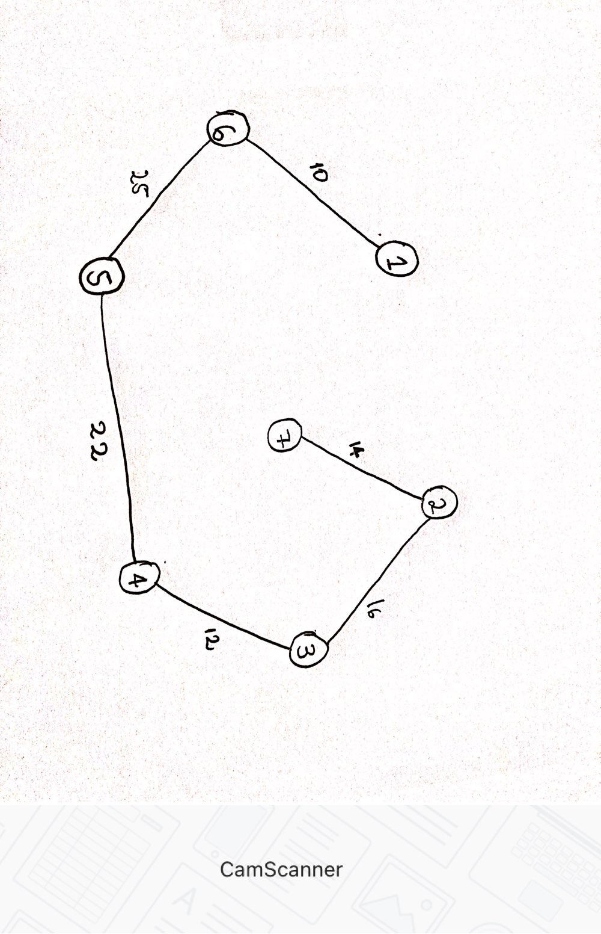

Total Weight
10 + 12 + 14 + 16 + 22 + 25 = 99

THE END

